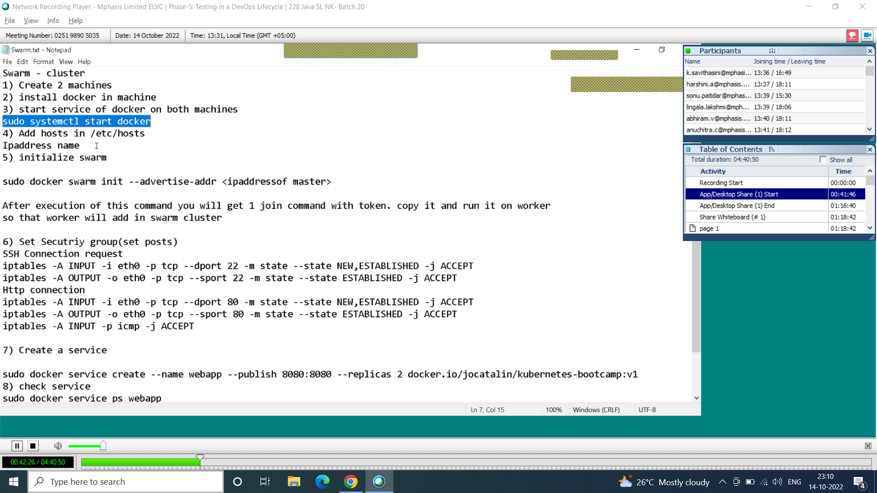

In docmaster

sudo yum update -y

sudo yum -y install docker

sudo systemctl start docker

sudo vi /etc/hosts

in docmaster

(privateIpaddress) dockermaster

(privateIpaddress) dockerworker

:q!

In docworker

sudo yum update -y

sudo yum -y install docker

sudo systemctl start docker

indocmaster

sudo docker swarm init --advertise-addr (ipaddressof master)

* Output: Vary -> docker swarm join --tocken dtgvmhjhjuf 132.788.76 ->copy paste in dockerworker
* In dockworker
* Sudo docker swarm join --tocken dtgvmhjhjuf 132.788.76-|
* If not come check in dockermaste sudo ->docker node ls |
* Repeat this ___|
* docker node ls
* till shows 2 ipaddress

indocmaster

SSH Connection request

iptables -A INPUT -i eth0 -p tcp --dport 22 -m state --state NEW,ESTABLISHED -j ACCEPT

iptables -A OUTPUT -o eth0 -p tcp --sport 22 -m state --state ESTABLISHED -j ACCEPT

Http connection

iptables -A INPUT -i eth0 -p tcp --dport 80 -m state --state NEW,ESTABLISHED -j ACCEPT

iptables -A OUTPUT -o eth0 -p tcp --sport 80 -m state --state ESTABLISHED -j ACCEPT

iptables -A INPUT -p icmp -j ACCEPT

* ping (ipaddress of dockworker)

inworker(disclaimer check if it works in anyone of the machine)

iptables -A INPUT -i eth0 -p tcp --dport 22 -m state --state NEW,ESTABLISHED -j ACCEPT

iptables -A OUTPUT -o eth0 -p tcp --sport 22 -m state --state ESTABLISHED -j ACCEPT

Http connection

iptables -A INPUT -i eth0 -p tcp --dport 80 -m state --state NEW,ESTABLISHED -j ACCEPT

iptables -A OUTPUT -o eth0 -p tcp --sport 80 -m state --state ESTABLISHED -j ACCEPT

iptables -A INPUT -p icmp -j ACCEPT

* ping (ipaddress of dockmaster)
* sudo docker service create --name webapp --publish 8080:8080 --replicas 2 docker.io/jocatalin/kubernetes-bootcamp:v1
* sudo docker service ps webapp
* curl localhost:8080

in note to edit inbound

then after ping in two of them

in master

sudo docker node ls

sudo docker swarm leave –force

sudo docker swarm init

* Output: Vary -> docker swarm join --tocken dtgvmhjhjuf 132.788.76 ->copy paste in dockerworker
* In dockworker
* sudo docker swarm leave –force
* Sudo docker swarm join --tocken dtgvmhjhjuf 132.788.76

Master :

sudo docker node ls

sudo docker service create --name webapp --publish 8080:8080 --replicas 2 docker.io/jocatalin/kubernetes-bootcamp:v1

sudo docker service ps webapp

in Master,worker curl localhost:8080

3rd part

In doc worker:

wget <https://amazon-eks.s3-us-west-2.amazonaws.com/1.10.3/2018-07-26/bin/linux/amd64/kubectl>

chmod +x kubectl

./kubectl

mkdir bin

cp ./kubectl $HOME/bin/kubectl && export PATH=$HOME/bin:$PATH

kubectl version

kubectl version --short --client

wget <https://amazon-eks.s3-us-west-2.amazonaws.com/1.10.3/2018-07-26/bin/linux/amd64/aws-iam-authenticator>

chmod +x ./aws-iam-authenticator

cp ./aws-iam-authenticator $HOME/bin/aws-iam-authenticator && export PATH=$HOME/bin:$PATH

apt install python-pip

pip install awscli

aws –-version

aws-iam-authenticator help

in fsd

curl -s https://packages.cloud.google.com/apt/doc/apt-key.gpg | apt-key add -

echo "deb http://apt.kubernetes.io/ kubernetes-xenial main" >/etc/apt/sources.list.d/kubernetes.list

apt-get update

apt-get install -y kubelet kubeadm kubec